Route 53

**53 is a port number of DNS**

**DNS is used for communication for the others computers**

Example we hit yahu.com -open the page of yahu.com but still this yahu.com communicate with DNS that means he lookup with DNS and check ki vo hamre system hai ky (yahu.com) uske related jo bhi ip hongi vo dhundta hai and you ip to ip communicate krta hai and hit on the (ip of yahu.com)

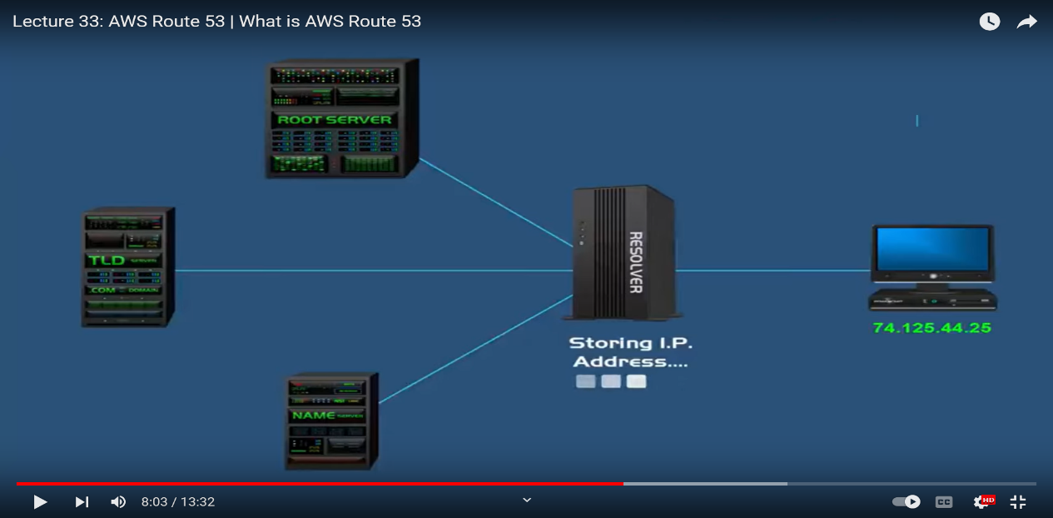

**Benefits of DNS**

Public domain names you own (or buy)

Private domains names that can can be resolved by your instance in your vpcs

**Route 53 has advanced features such as**

Load balancing (through DNS – also called client load balancing )

Health checks (although limited )

Routing policy : simple, failover, geolocation, latency, weighted, multi value

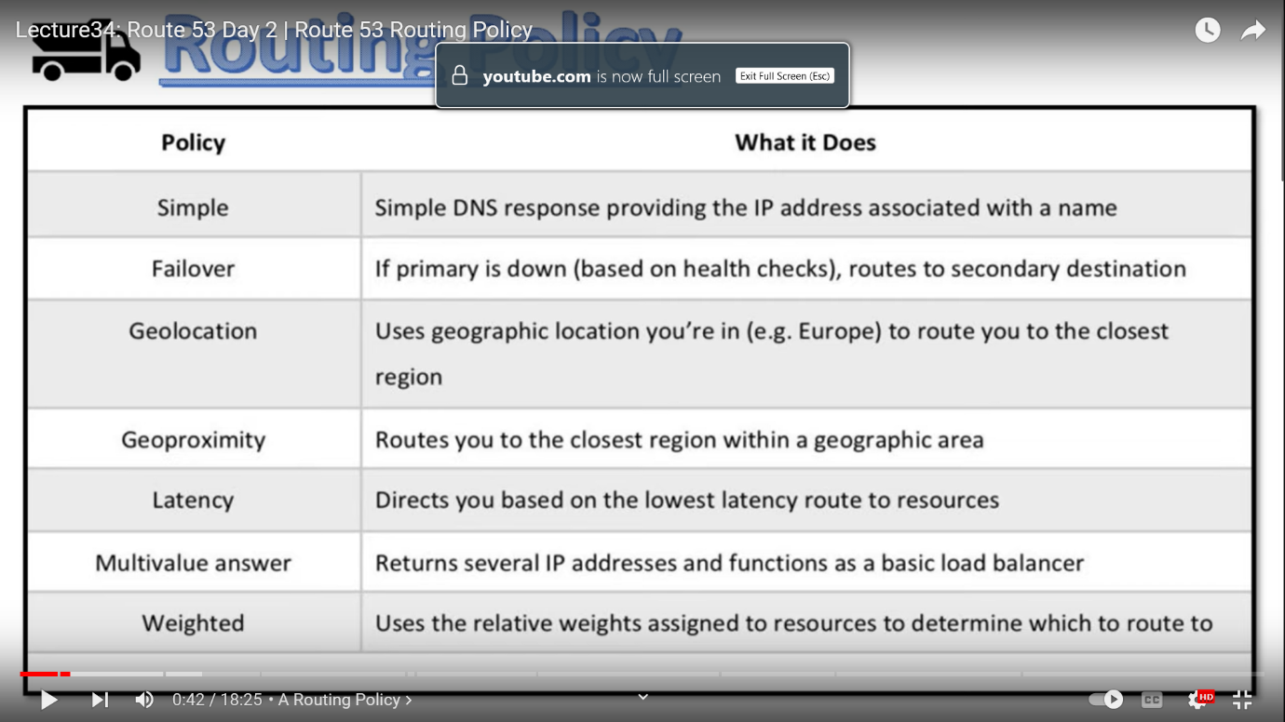

Simple policy 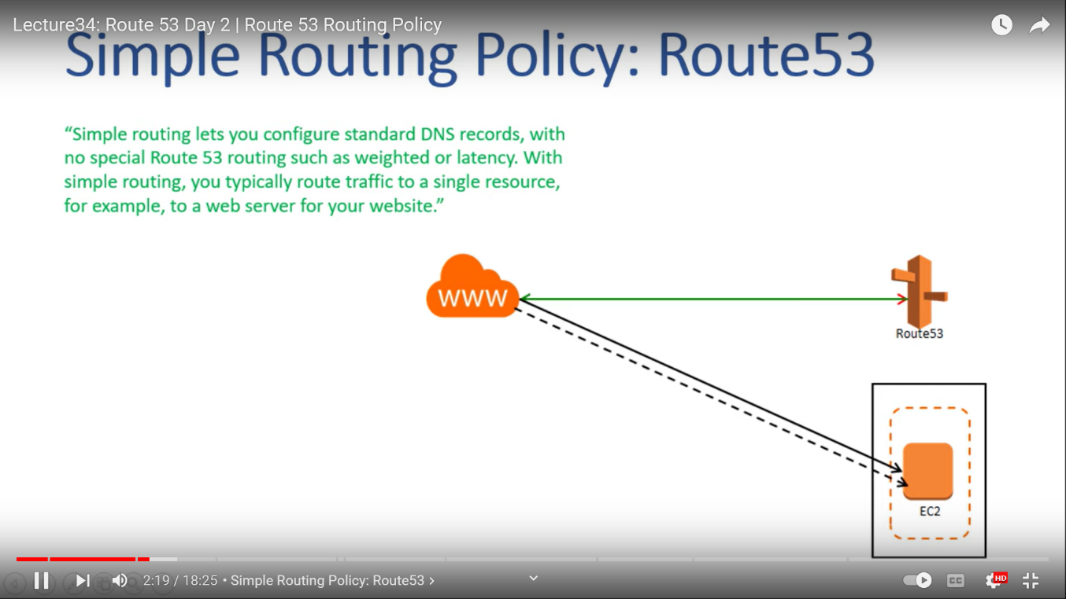

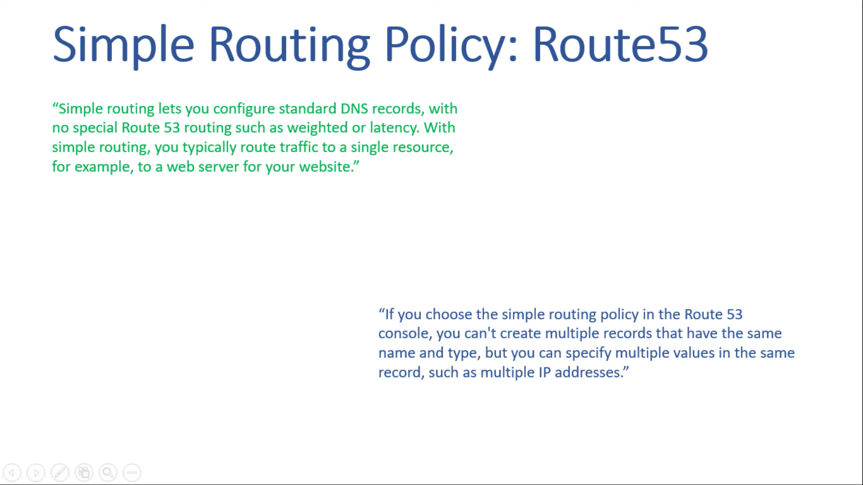

**We can apply multiple ip allocated to the simple policy**

## Failure policy

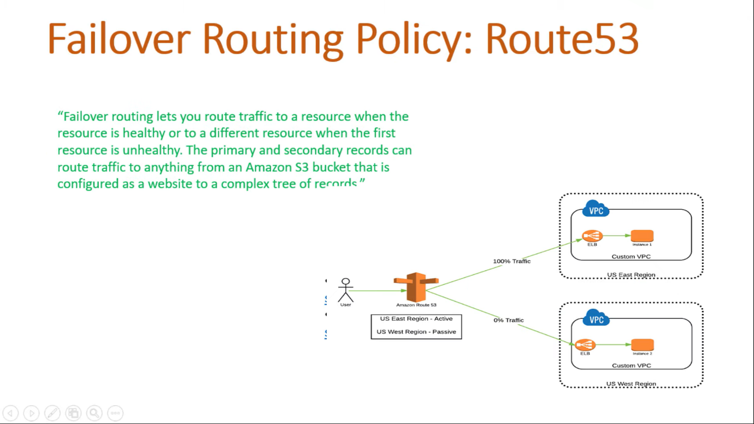

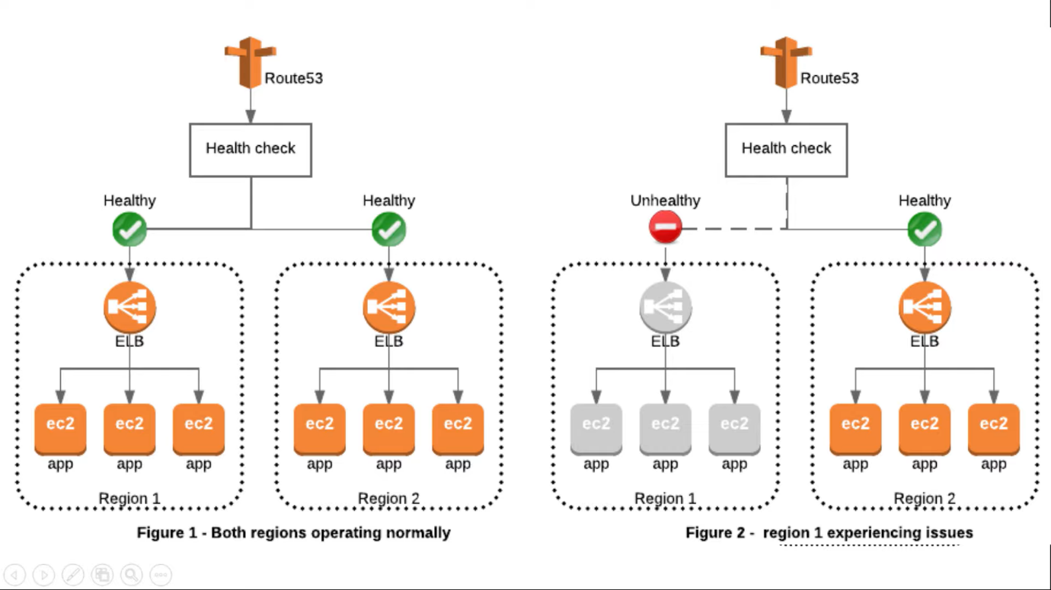

**This is the example of failure policy agr koi ek instance pe load badhenga to automatic load secondary instance pe jayenga**

# Geolocation routing policy :

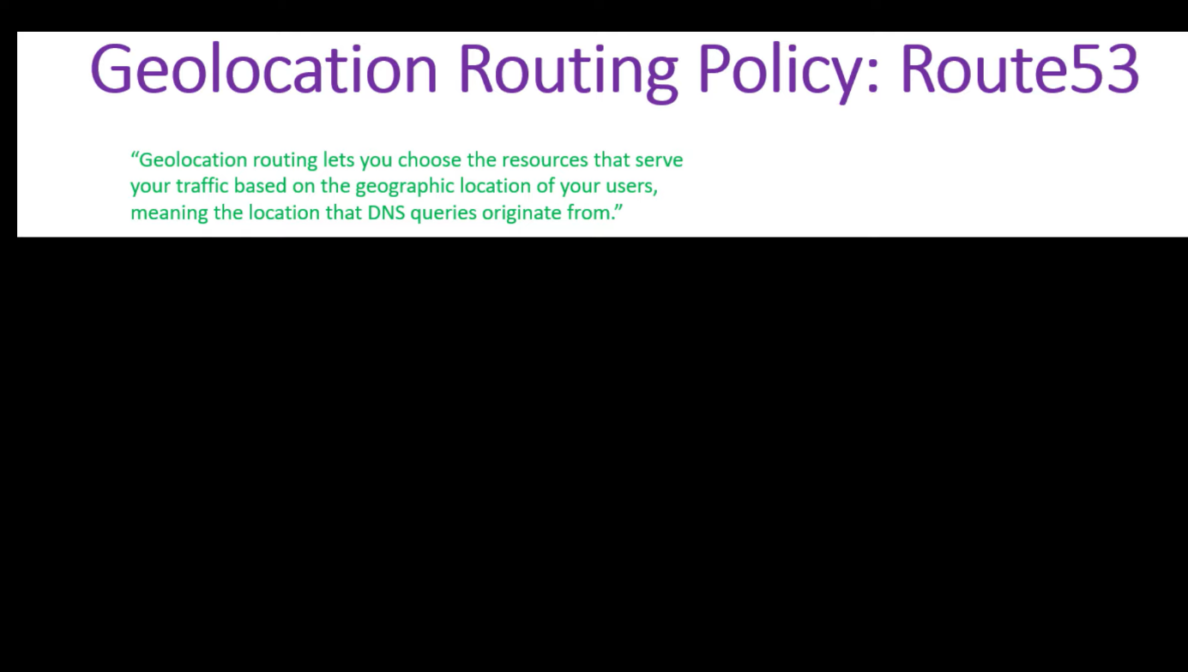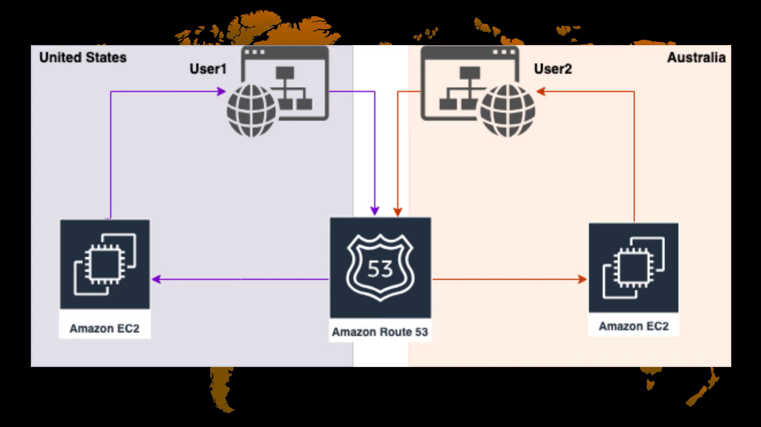

Example :- google.com agr tum hit kronge to side me india lika ata hai q ki vo india k server pe run kr rha hai not other country

Agr hame koi country me website ban krni hai to ham geolaction se ban kr skte hai

# Geoproximity policy

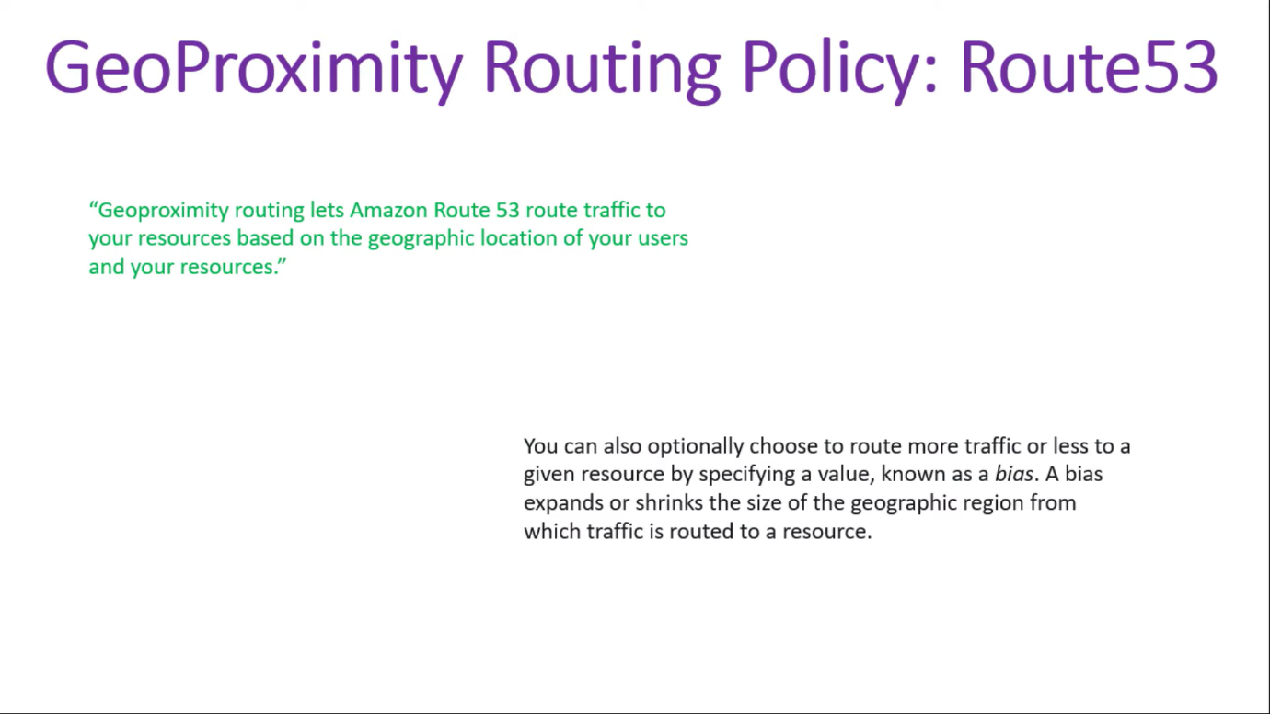

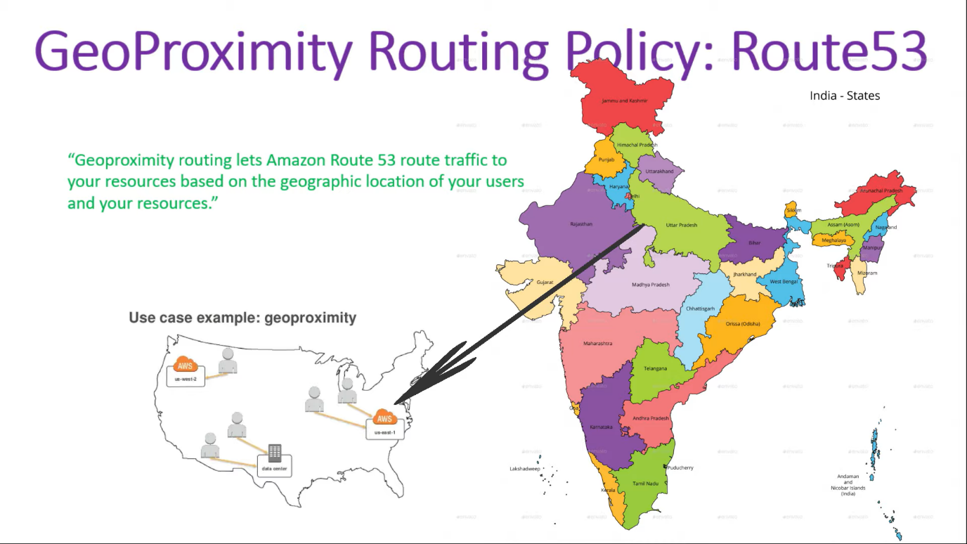

Geoproximity me ham ek hi region me multiple server lagte hai if agr delhi se ip hit hori hai to vo sirf delhi k server me hi hit hongi agr koi Mumbai me hai vha se vo site hit kra hai to vo Mumbai k server me hi hit hongi area k according vo load balancer krta hai 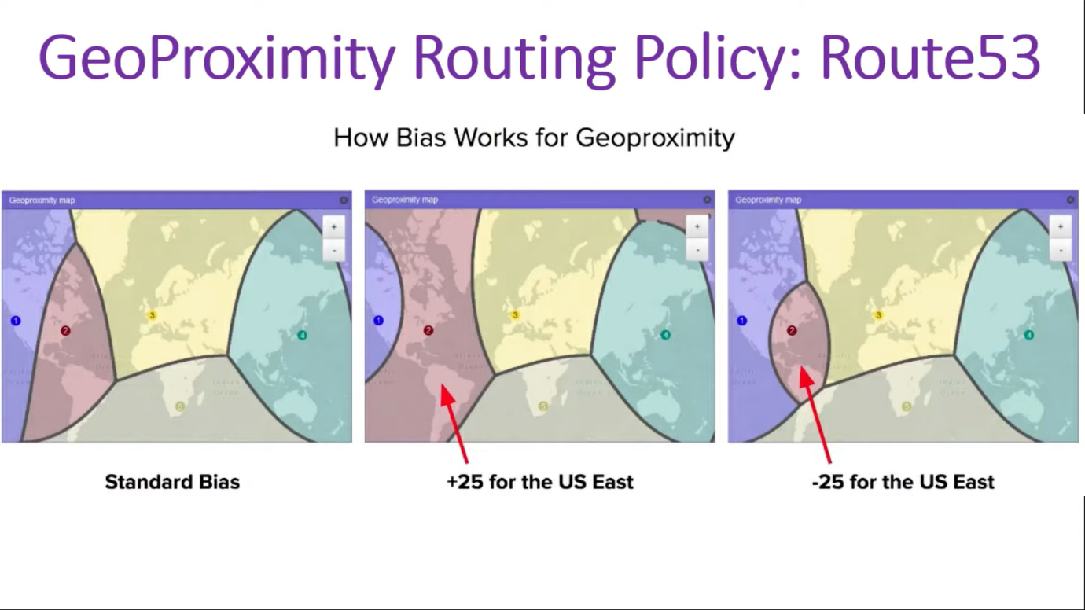

Agr traffic UP se jyada ara honga to ham use divert krke size jyada kr skte hai

# Latency based policy

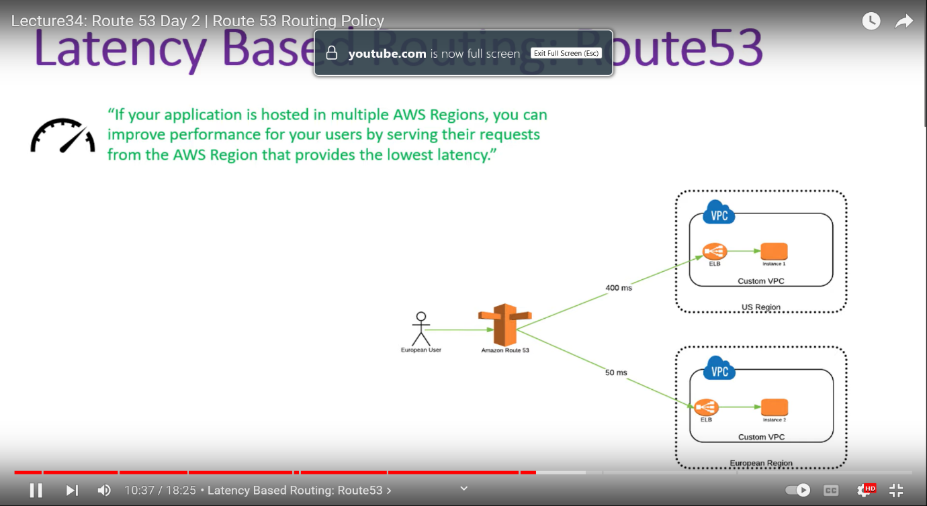

# Multivalue answer routing policy

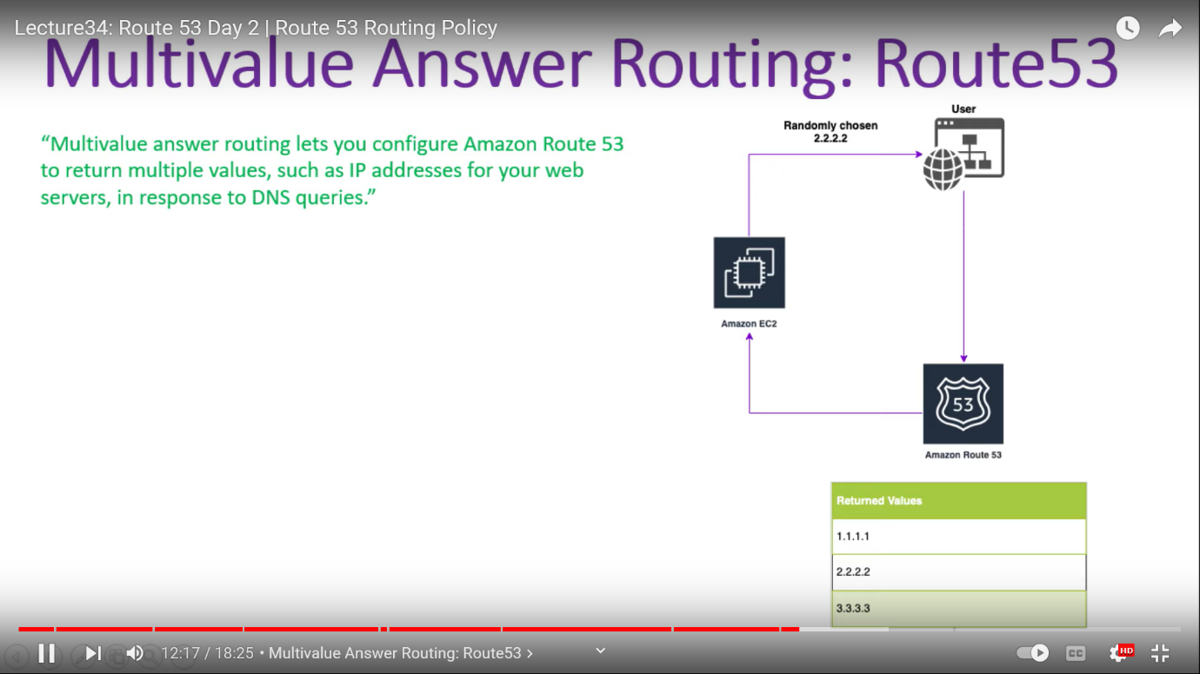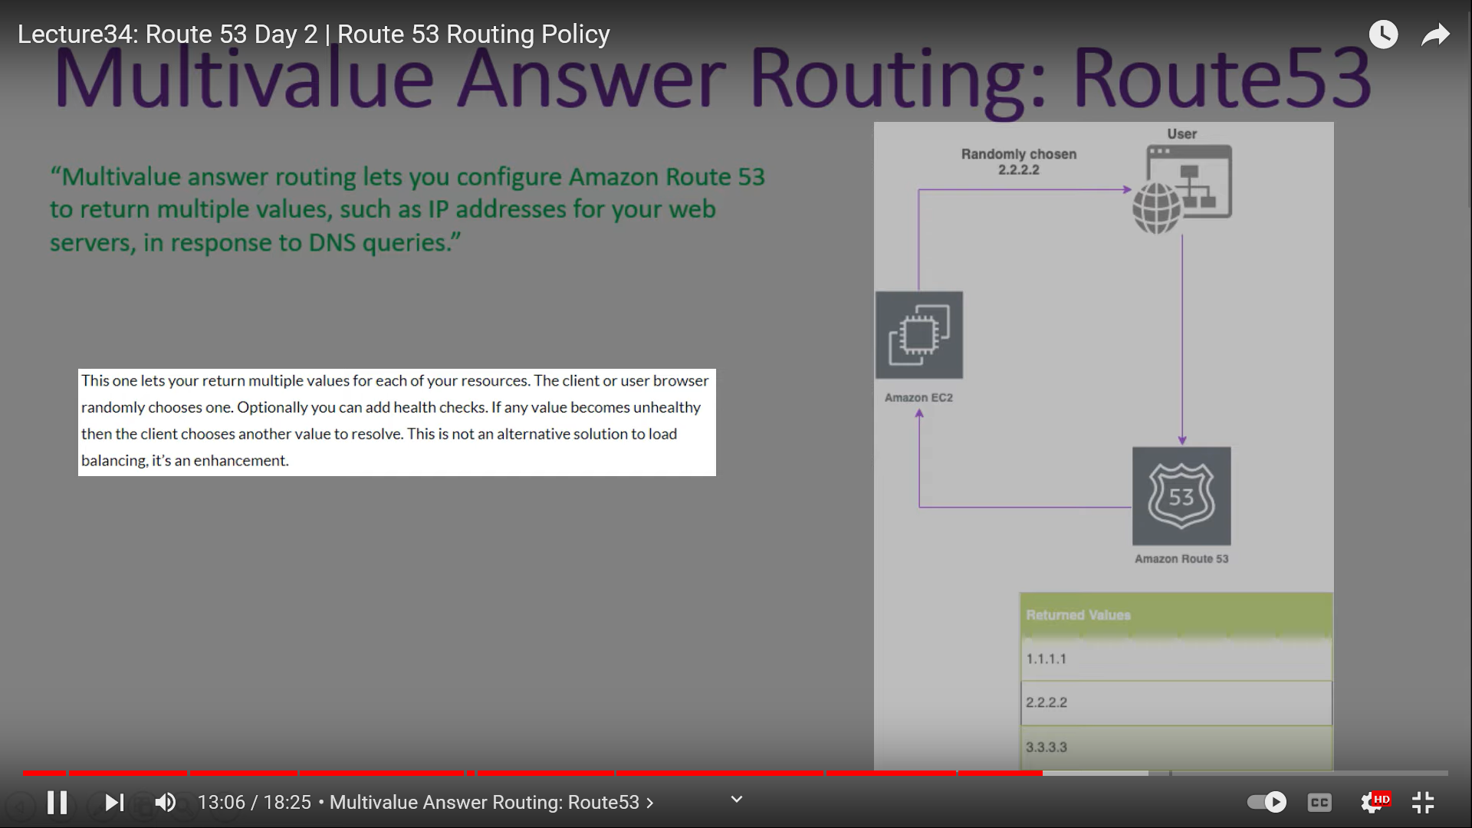

# Weighted routing policy

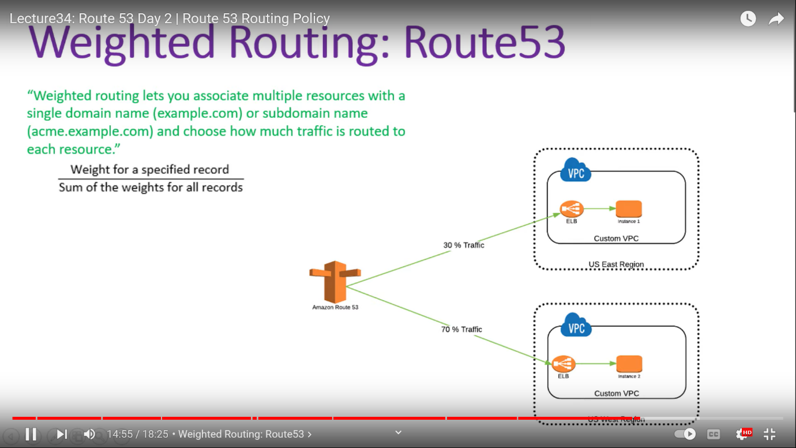

[**https://youtu.be/DrD6Y0dHfr0**](https://youtu.be/DrD6Y0dHfr0) **link of youtube channel**